Heroku Installation steps

Tools needed

1. node and npm

2. heroku toolbelt (heroku toolbelt gives to access to command line)

3. git

1. create your account at heroku

2. install heroku toolbelt

once you install toolbelt go to command line and type heroku

This will install all the dependencies

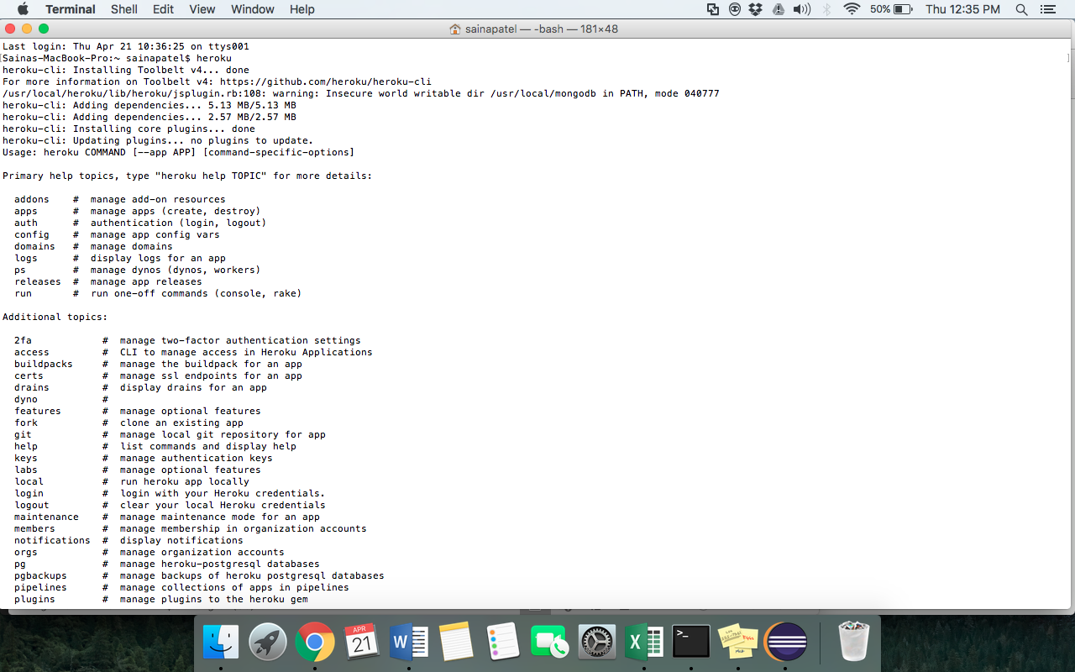

3. Login into your account using heroku login

4. create a repository using command

heroku create repo_name

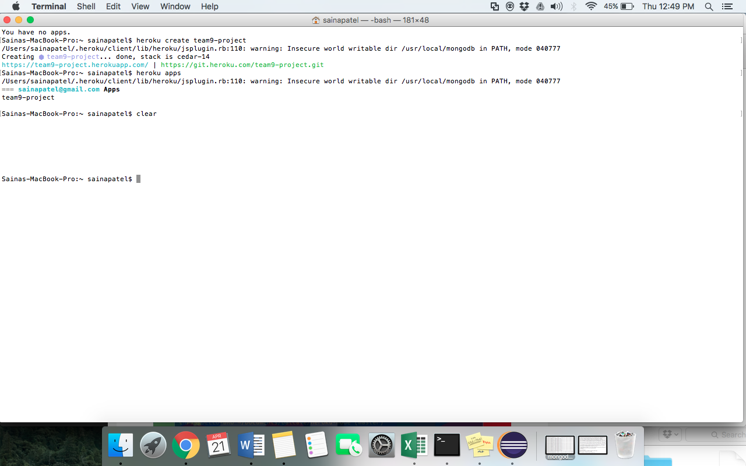

to check all of your apps use command

heroku apps

(as given in above screenshot)

To check error logs type heroku logs –app app_name

Note: there is one more way to create app directly from dashboard

Then open your heroku dashboard there you will see the app you just created.

Click on the app, There in Deploy go and select github(it will connect to your github account)

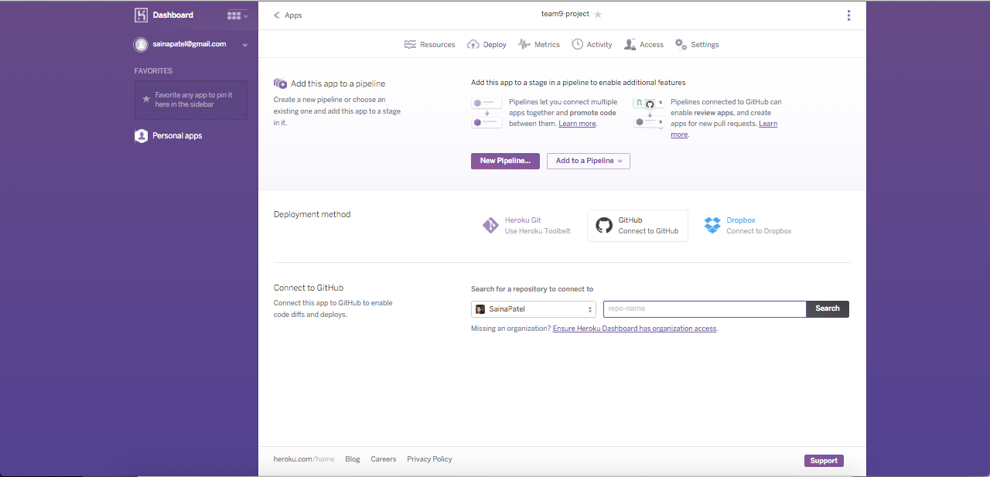

select the repository and connect

Then click on deploy branch

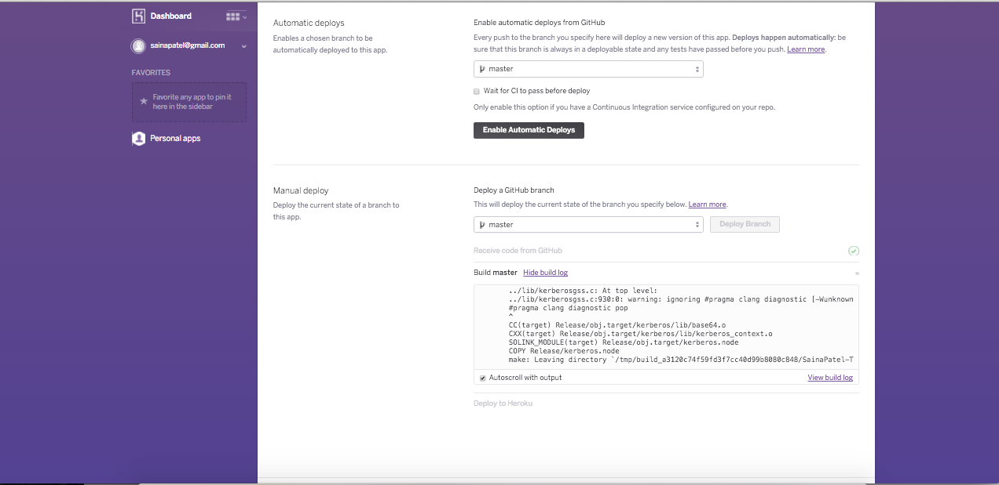

Once it is deployed you will see a button View. Click on it to open your app.

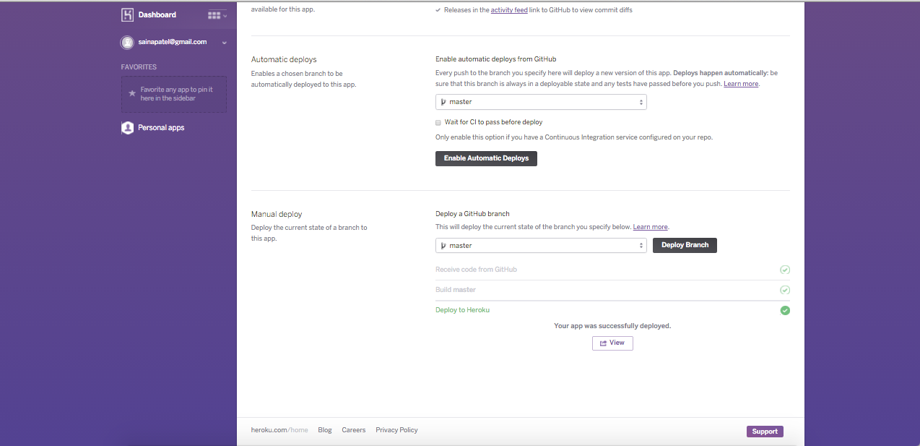

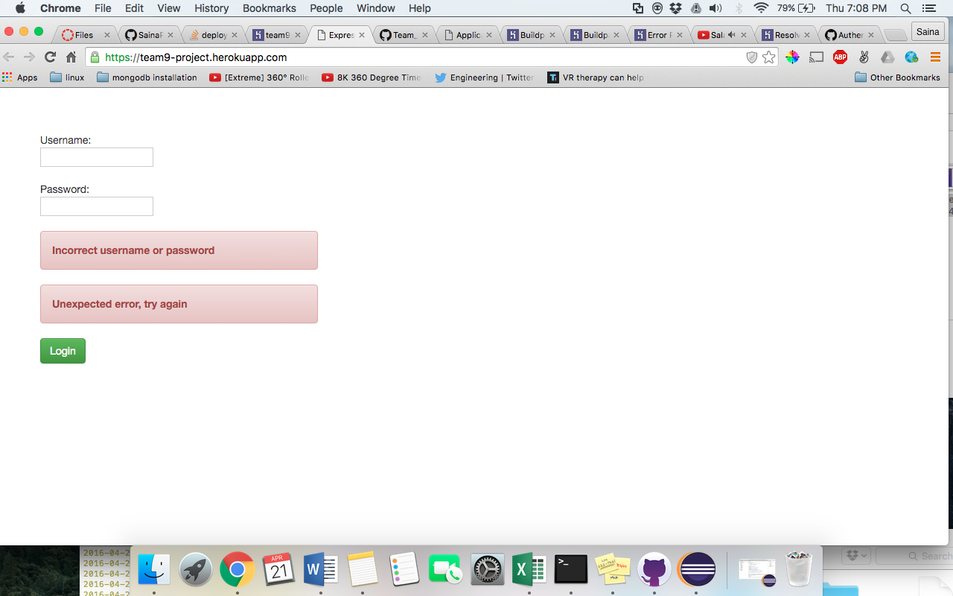

As heroku is looking for package.json and all files in root directory, I have kept all the files of project in root.

Solution of errors if you get these

1. Buildpack error

clear all the buildpacks attached to your project by

heroku buildpacks:clear --app app-name

now after this heroku will look at your package.json and identify what all dependencies need to be included.